**Board of Directors**

Jorge Magana, President

Steve Dietrich, Vice President Matthew Starbuck, Director Jim Keeling, Director

Glen McLeod, Director

1550 East Burton Mesa Blvd, Lompoc

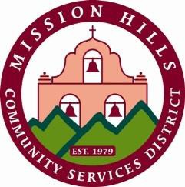California, 93436-2100

805.733.4366

[www.mhcsd.org](http://www.mhcsd.org/) Mike Garner, General Manager

**Mission Hills Community Services District**

**SPECIAL MEETING**

**Water & Wastewater Committee**

**Wednesday October 22,2025**

4:30 PM

1550 East Burton Mesa Blvd, Lompoc, CA - District Conference Room

**Agenda**

1. **Call to Order and Pledge of Allegiance**
2. **Roll Call**
3. **Public Comment**

Members of the public may address the Committee regarding any items on this agenda. Public comments and suggestions are limited to three minutes.

1. **Discussion**
   1. Discuss the Capital Improvements Project Protocol

**ADJOURN**

**In compliance with the Americans with Disabilities Act**

If you need special assistance to participate in this meeting or if you need the agenda or other documents in the agenda packet provided in an alternative format, contact the Board Secretary at 805.733.4366 at least 48 hours before the meeting to ensure that reasonable arrangements can be made. (Agenda prepared under government Code section 54954.2)